Day 4

Q.1 Best Practices

Try to create a playbook using best practices and use play name , task name , correct modules , use native syntax

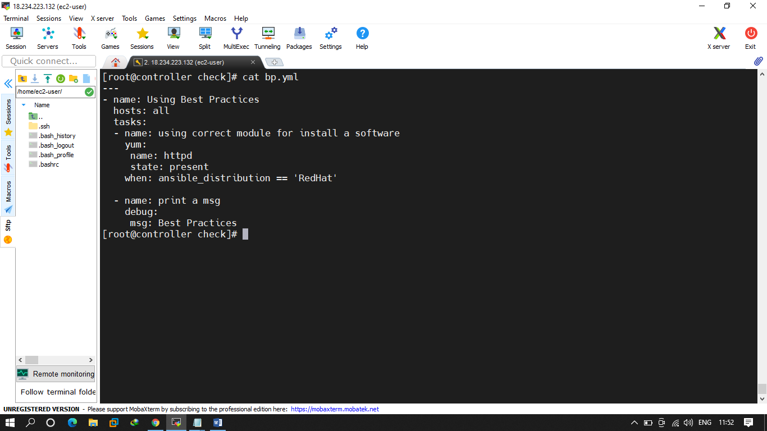

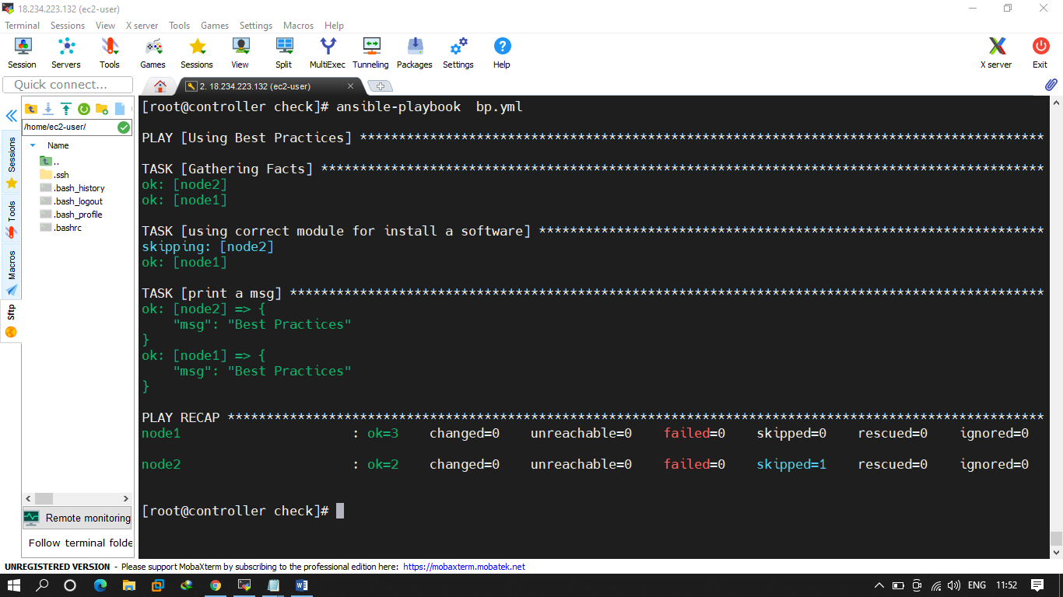

Q.2 FILTERS

Try to create yaml with one file have break and another one doest have break.

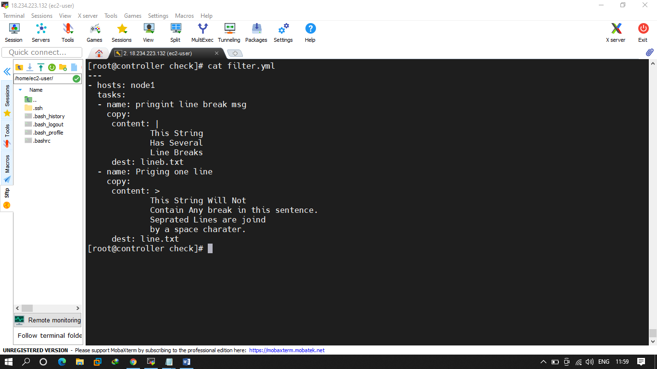

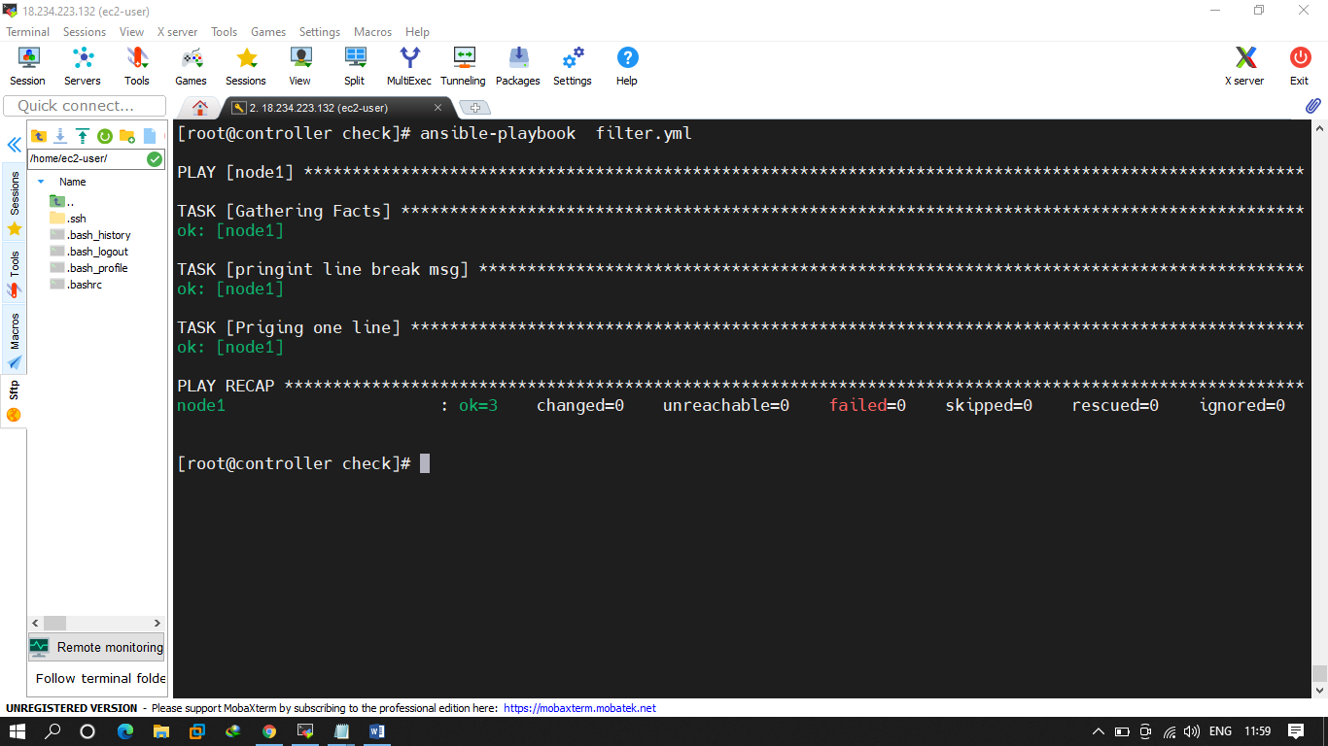

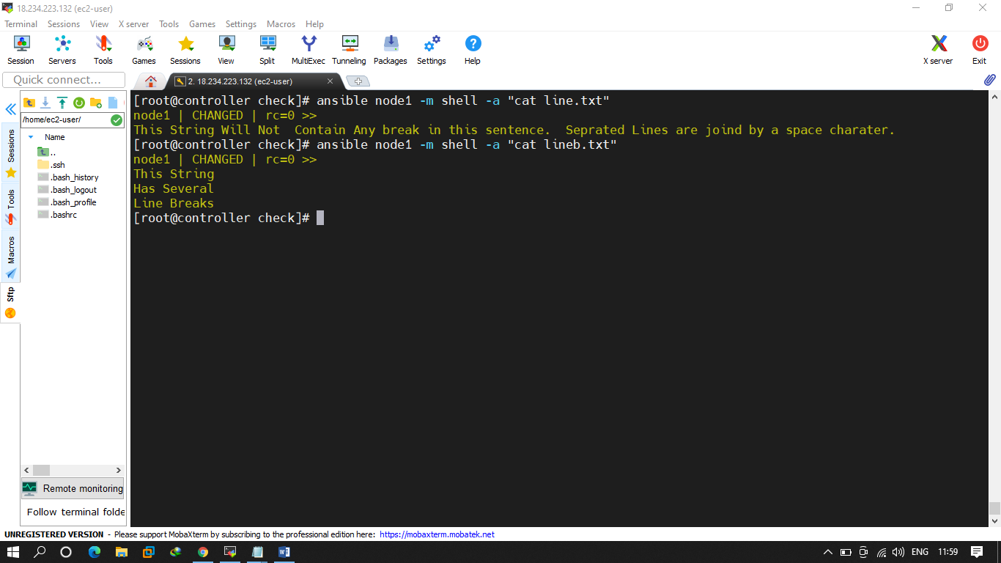

Try to create a yaml that will generate everytime a random msg

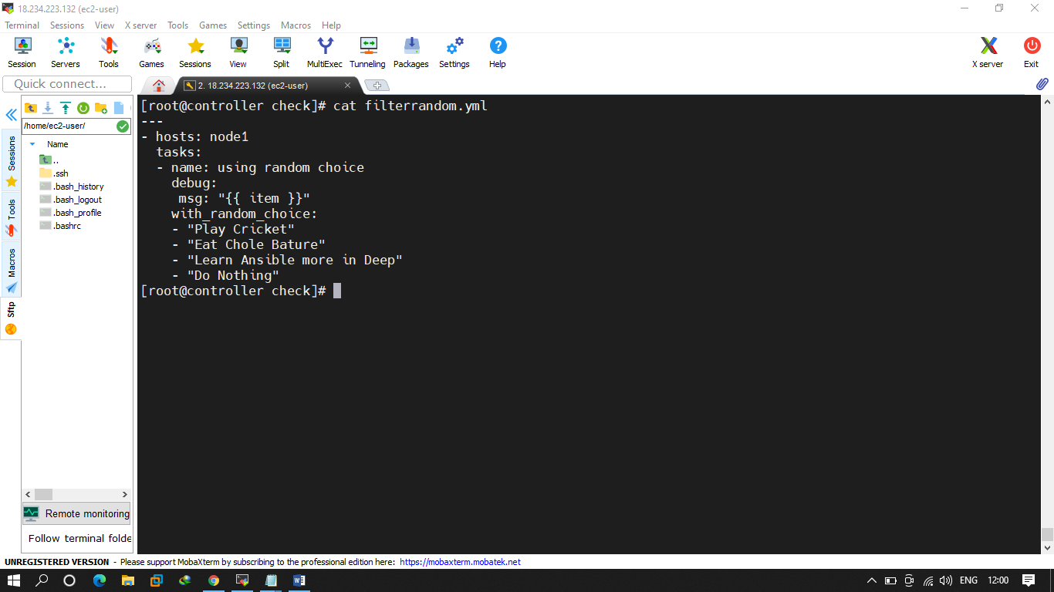

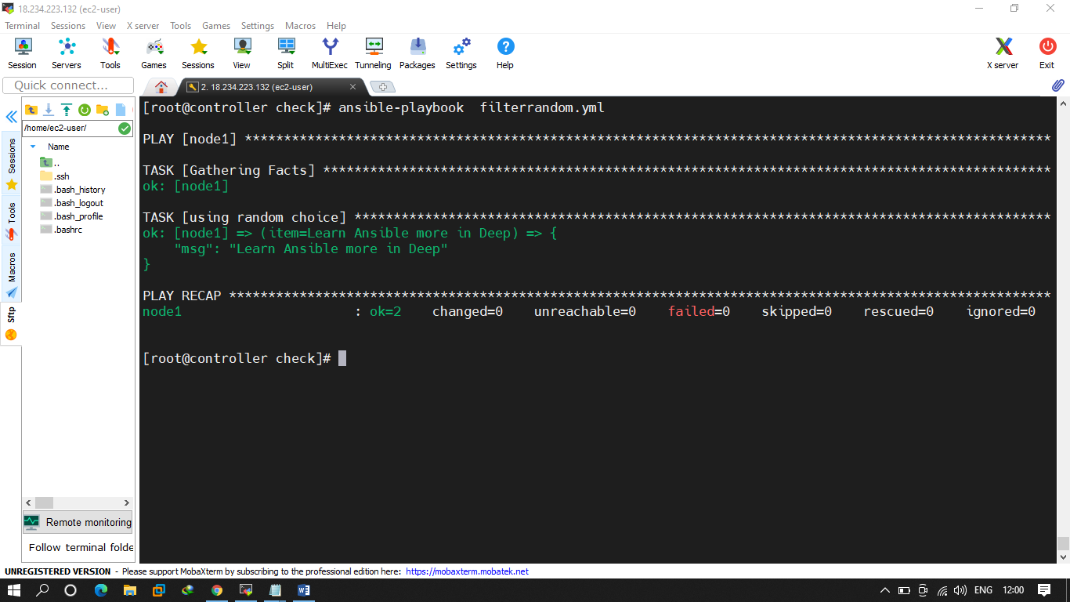

Q.3 Plugins

Try to add users and user list is in a file user._list.yml , lookup plugin u have to use. And them a password as well. And password file should be save in current location with file name password-username. The first middle and last name of the user should be capitalize . add uid as well.

